Soluzione
modo # 1: 0.68799 [Hz] -1 -0.0068842 -0.004842
modo # 2: 3.8842 [Hz] 0.7909 -1 -0.79904
modo # 3: 11.2249 [Hz] 0.031377 -0.040809 1

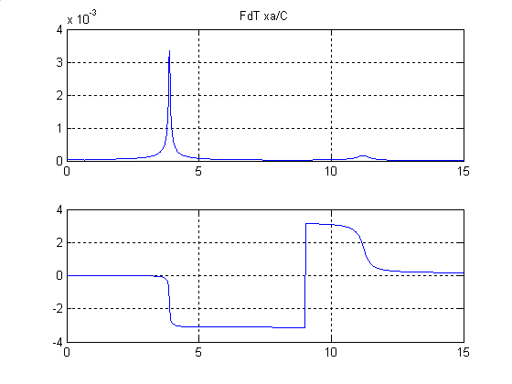 | 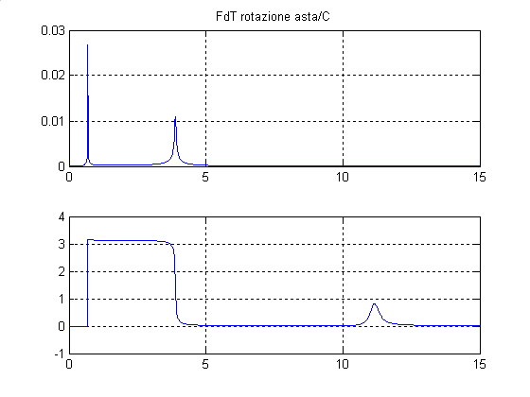
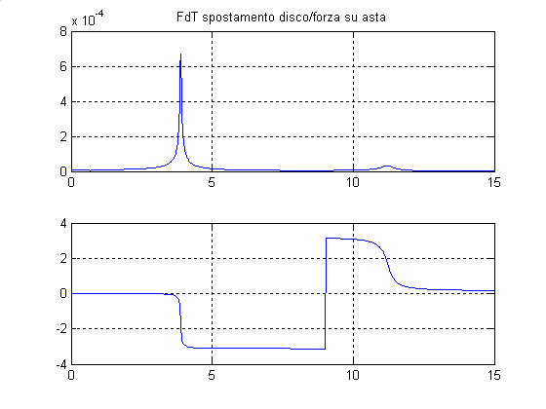 | 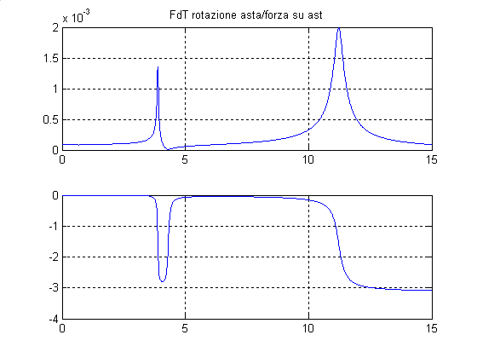

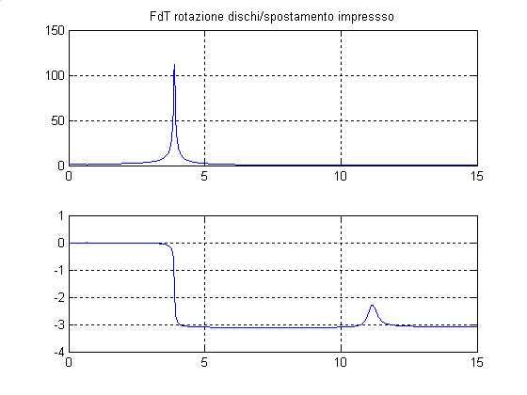 | 